DEAF-BLIND SERVICE CENTER PRO-TACTILE NEWS – OCTOBER 2014

Message from Angela Theriault, Executive Director

Happy FALL! Hope you enjoy seeing the different beautiful leaves and feeling the chilly wind. Believe it or not – it is October!

Happy reading the Pro-Tactile Newsletter!

Message from Jorge Aristizabal, Board President

Hello everyone in the DB Community – DB, SSPs, Deaf, Hard of Hearing, Hearing, and Sighted – Everyone!

Fall is here and we are looking forward to the trees changing colors and eventually losing their leaves. But we are also sad because this means that it will be getting darker sooner because of the time change. Remember to set your clocks back on Sunday, November 2nd.

Last August, Michelle resigned from DBSC’s board. We want to thank her for all that she has done over the years, the many hours of volunteering, and her support for DBSC – Thank you, Michelle! The board is now searching for two more volunteers to join our board. It doesn’t matter if they are hearing, deaf, or DB. If you or someone you know is interested, contact me.

September 13th was our annual Walk-A-Thon. It was a great success. We raised around $4,541.00! Many thanks to our committee, especially to Nancy Sommer for all her hard work – she did an awesome job – the best! – #1

During our October board meeting we will be discussing future plans for events that you can look forward to! If you are interested in being on our fundraising committee, please let me know.

And lastly - some exciting news! Last weekend was the Deaf Expo in Tacoma. DBSC had a lot of people stop by our table and wanted to know how to become an SSP!

ODHH Funding
We are thrilled to announce that DBSC received $65,500 from ODHH (Office of Deaf and Hard of Hearing) for the SSP program. Thank you, ODHH for supporting DBSC’s mission to provide more independence!

Walk-A-Thon
This year’s Walk-A-Thon was a very successful fundraising event which happened on Saturday, September 13th at Alki Beach in West Seattle. The weather was perfect – blue sky – shining sun – windy beach. Some of our walkers enjoyed walking the trail following the lake, while others enjoyed riding the tandem bikes and surreys.

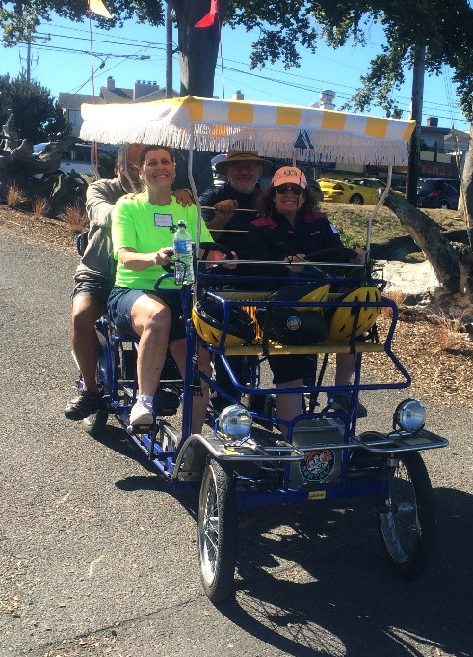
Congratulations to Debbie Sommer who won for gathering the most donations! Pictured on left is Debbie Sommer, Andrea Kurs, Clem Provatakis, and a bike captain from Wheel Fun in a surrey.

Lastly, hats off to the amazing teamwork of the Walk-A-Thon committee! Pictured below is Nancy Sommer, Jorge Aristizabal, and Merrilee Avila.
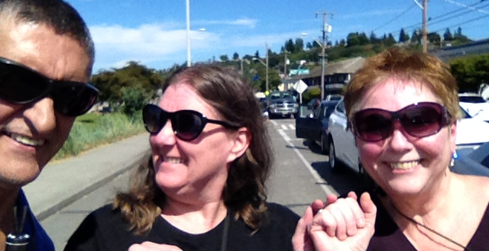

DBSC Staff Changes
We say farewell to JennyLynn Dietrich. After working as one of DBSC’s case managers for the past four years, JennyLynn has decided to pursue a master’s degree in Rehabilitation Counseling from Western Oregon University. We wish her good luck in her future endeavors!

Cathy Hoog, who was DBSC’s SSP coordinator, is now a case manager. While we will miss her dedication as SSP coordinator, we are excited about the experience and skills she will bring to her new position! Cathy’s email address is choog@seattledbsc.org.

Elizabeth Bass has been DBSC’s administrative assistant for the last two and a half years. Her husband will be transferring to Heritage University next semester, which means they will be moving to Yakima at the end of the year. Her last day at DBSC will be December 23rd. The staff thanks her for her wonderful skills and creativity. DBSC will miss her! If you are interested in applying for the full-time position of Administrative Assistant, here is the link: http://seattledbsc.org/administrative-assistant-job-posting/.

Finally, DBSC wants to say with much gratitude “Thank you!” to Merrilee Avila who has been involved with DBSC for more than 15 years. She has served on our board and many committees, sharing her passion for volunteering and socializing in the DeafBlind community. Merrilee and her husband have moved Nevada and we wish them the best in this new chapter of their lives.
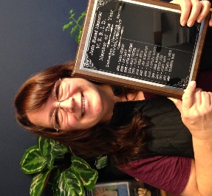

Congratulations
Elizabeth Bass was presented with WSRID’s Judie Husted Member of the Year Award. We are very proud of her. Some of the past recipients include: Theresa Smith, Ellie Savidge, Jeff Wildenstein, Anne Del Vecchio, and Joey Graff.
Picture on right is of Elizabeth with the award.

AmazonSmile
If you shop Amazon.com, try AmazonSmile. AmazonSmile is part of Amazon.com. The difference is when customers shop on AmazonSmile, the AmazonSmile Foundation donates 0.5% of the price of eligible purchases to the charitable organization selected by the customer.

When first visiting AmazonSmile, customers are prompted to select a charitable organization. After selecting their favorite organizations customers may browse or shop at AmazonSmile. There is no cost to the charitable organizations or to the customers and AmazonSmile does not deduct any fees from the donation amount.

So visit: www.smile.amazon.com, select DBSC as your charity, and have fun shopping!

Donate to DBSC
If you would like to donate DBSC’s programs & services, you can donate on our DBSC website, visit www.seattledbsc.org/donate!

DBSC is on Facebook! https://www.facebook.com/pages/The-Deaf-Blind-Service-Center/307809821674

Deaf-Blind Service Center
1620 18th Avenue, Suite 200, Seattle, WA 98122
VP (206) 455-7932 ● TTY (206) 323-3644 ● Voice Line: 206-323-9178
info@seattledbsc.org ● www.seattledbsc.org
To unsubscribe from the Pro-Tactile E-News, email info@seattledbsc.org

